**Current Gate Pass**

Production Link: <http://ampigatepass/>

Test Link: <http://ampiappdev1:8092/>

Landing Page:

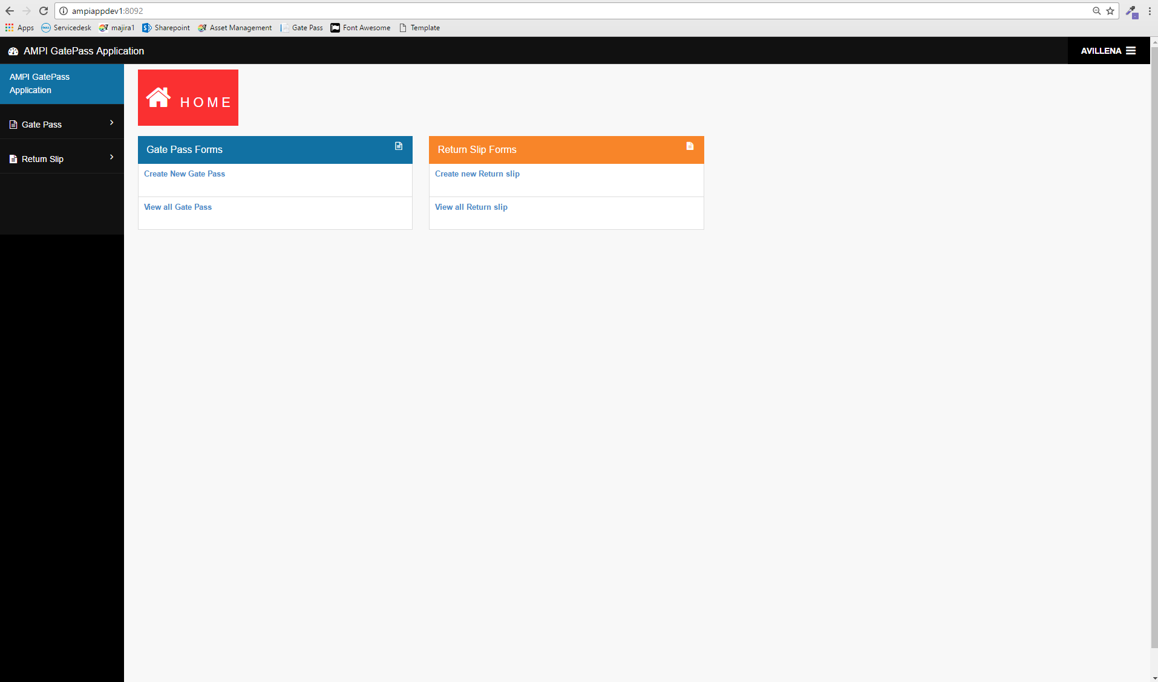

Gate Pass Menu -> Create New Gate Pass:

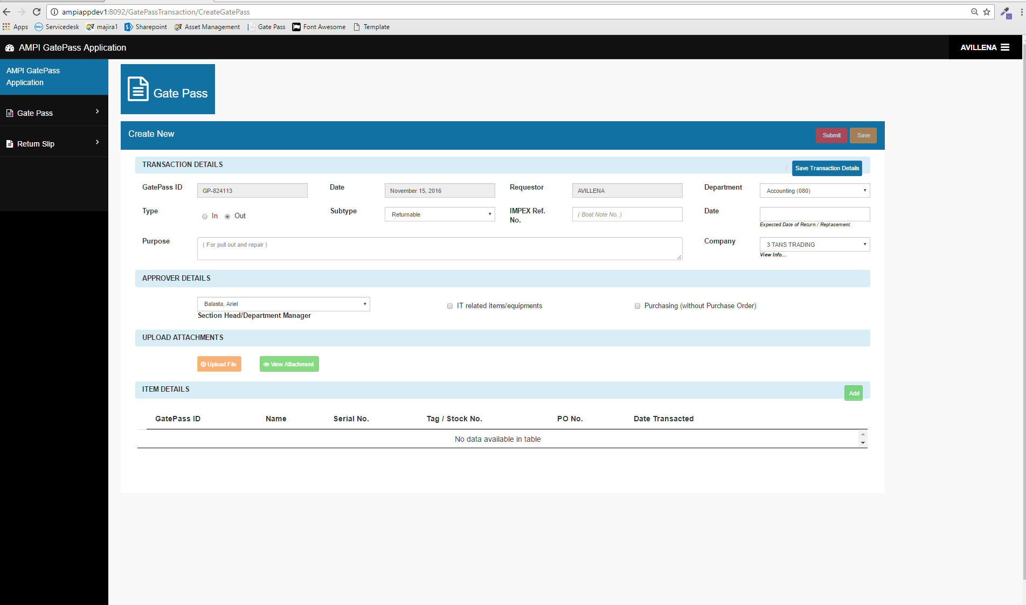

Gate Pass Menu -> Create New Gate Pass -> Add Item

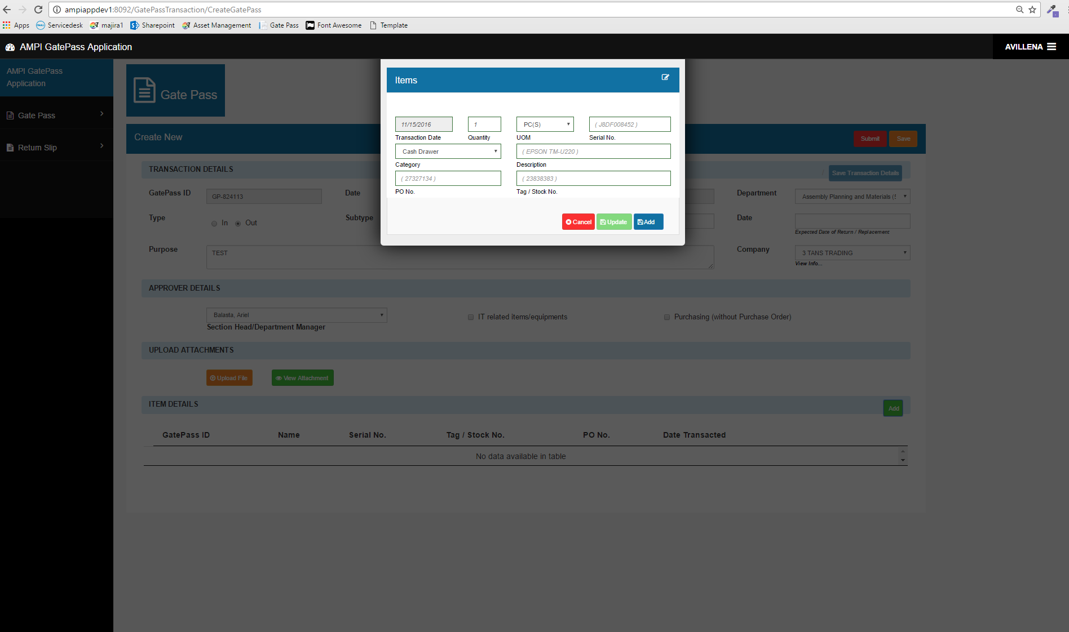

Gate Pass Menu -> View all Gate Pass

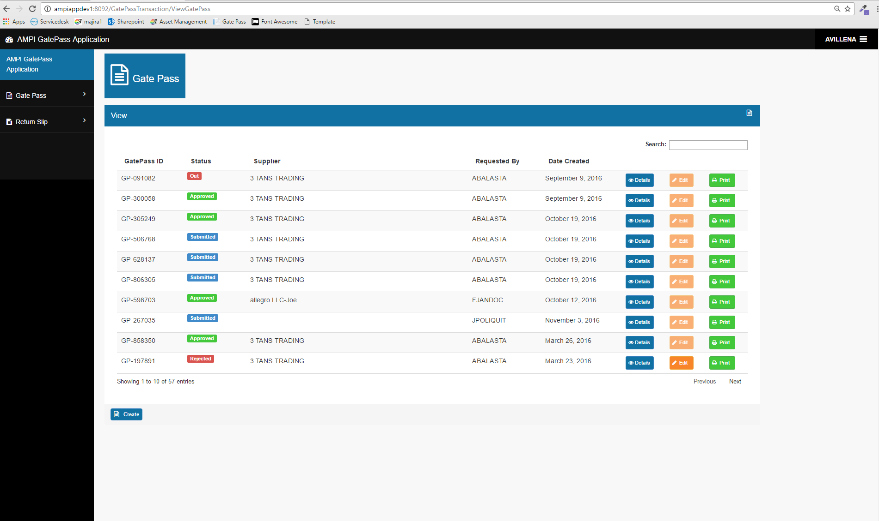

Gate Pass Menu -> View all Gate Pass -> Details

* To view Gate Pass details

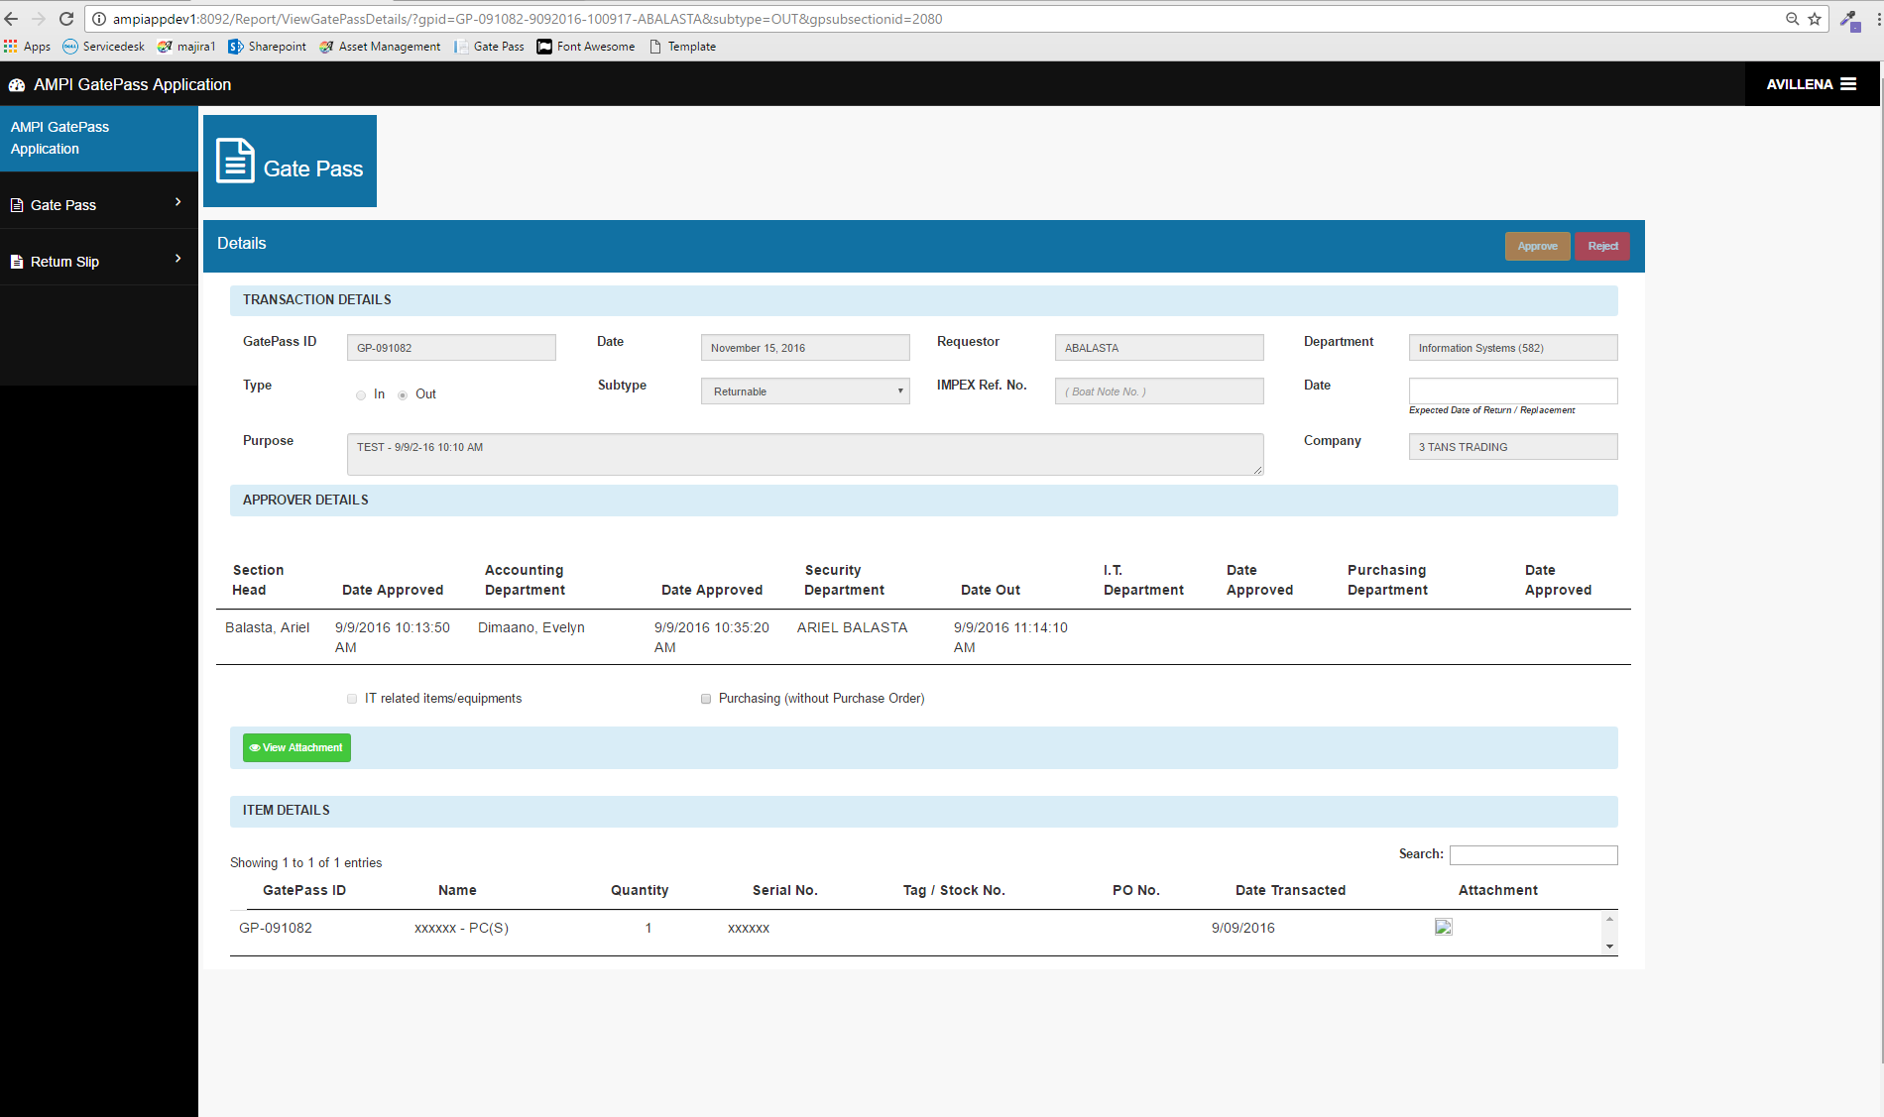

Gate Pass Menu -> View all Gate Pass -> Edit

* Editable Gate Pass details, Save as draft

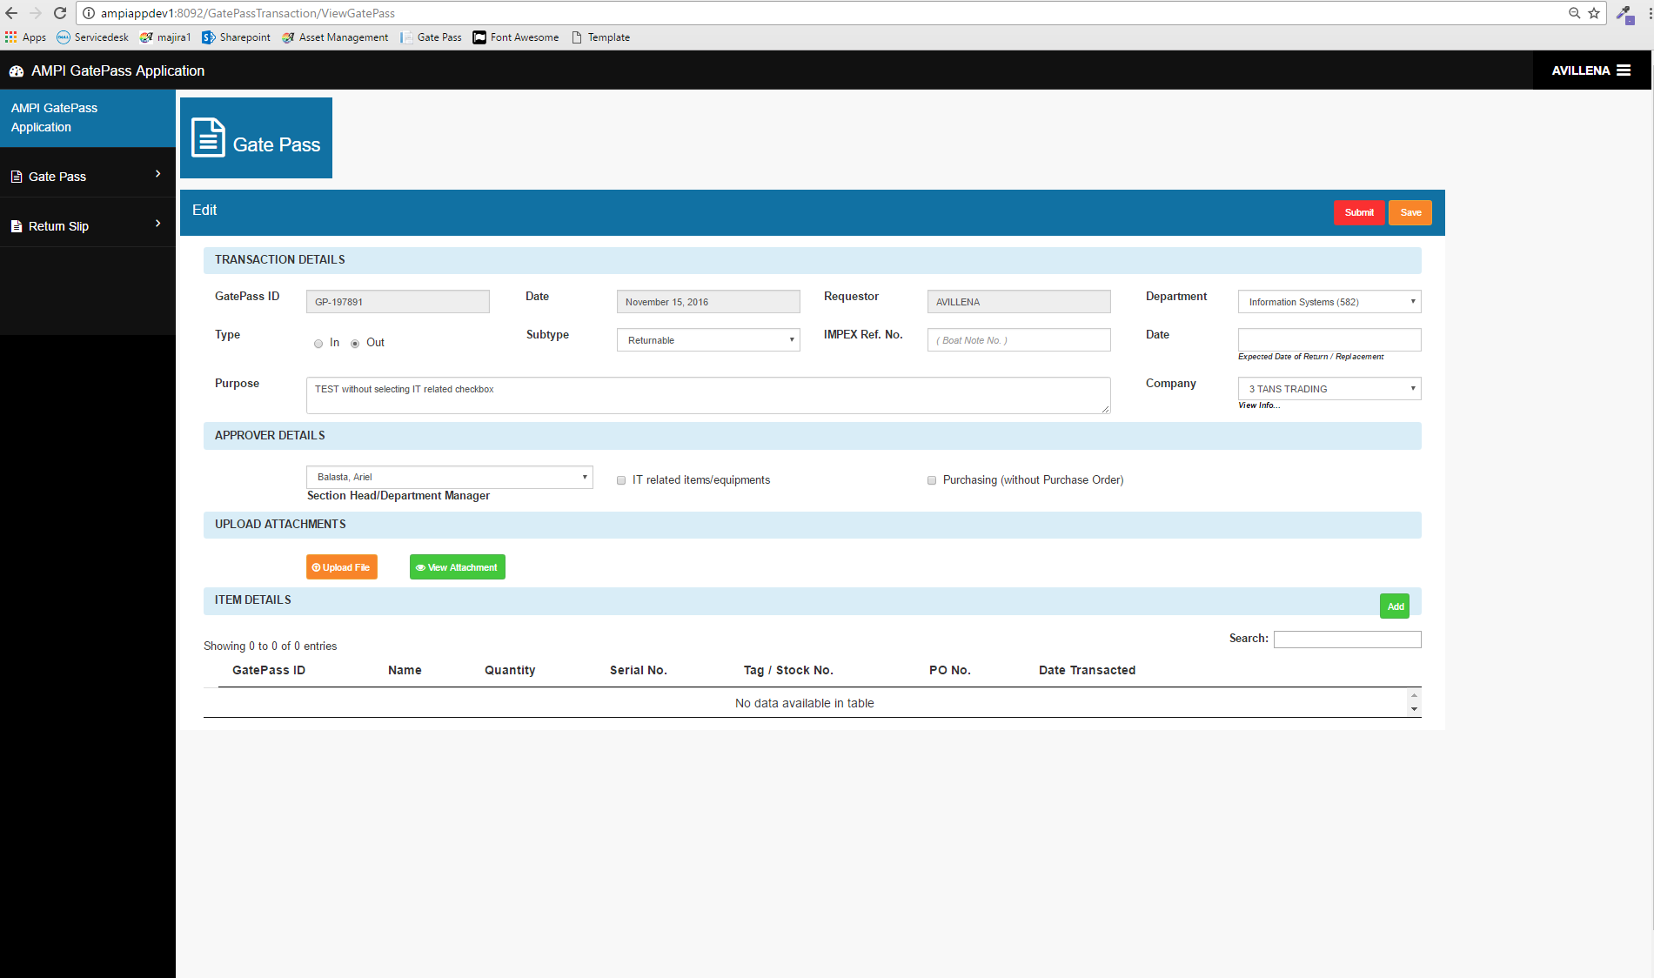

Gate Pass Menu -> View all Gate Pass -> Print

* For hardcopy

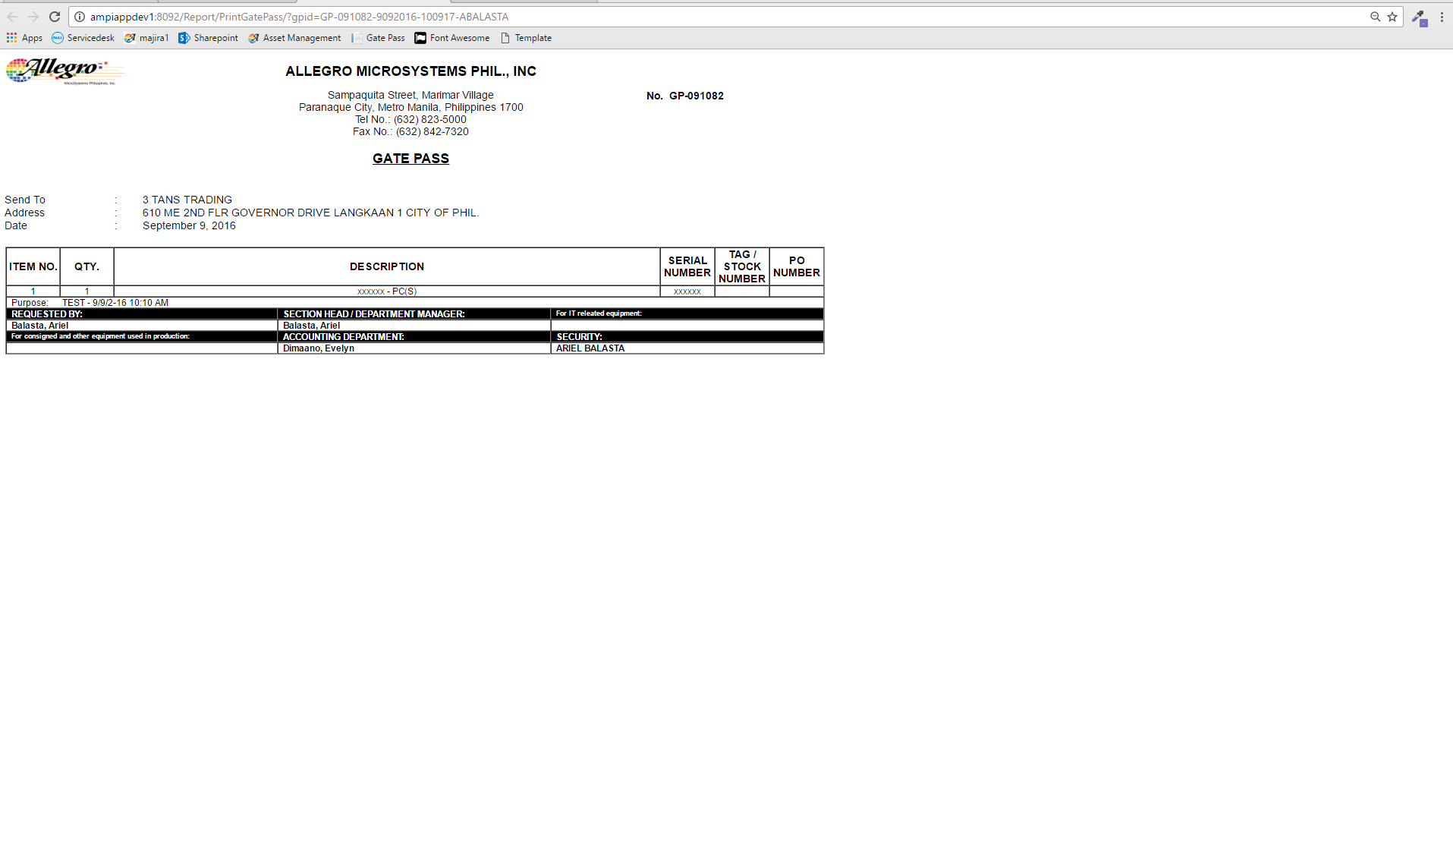

Return Slip Menu -> Create New Return Slip

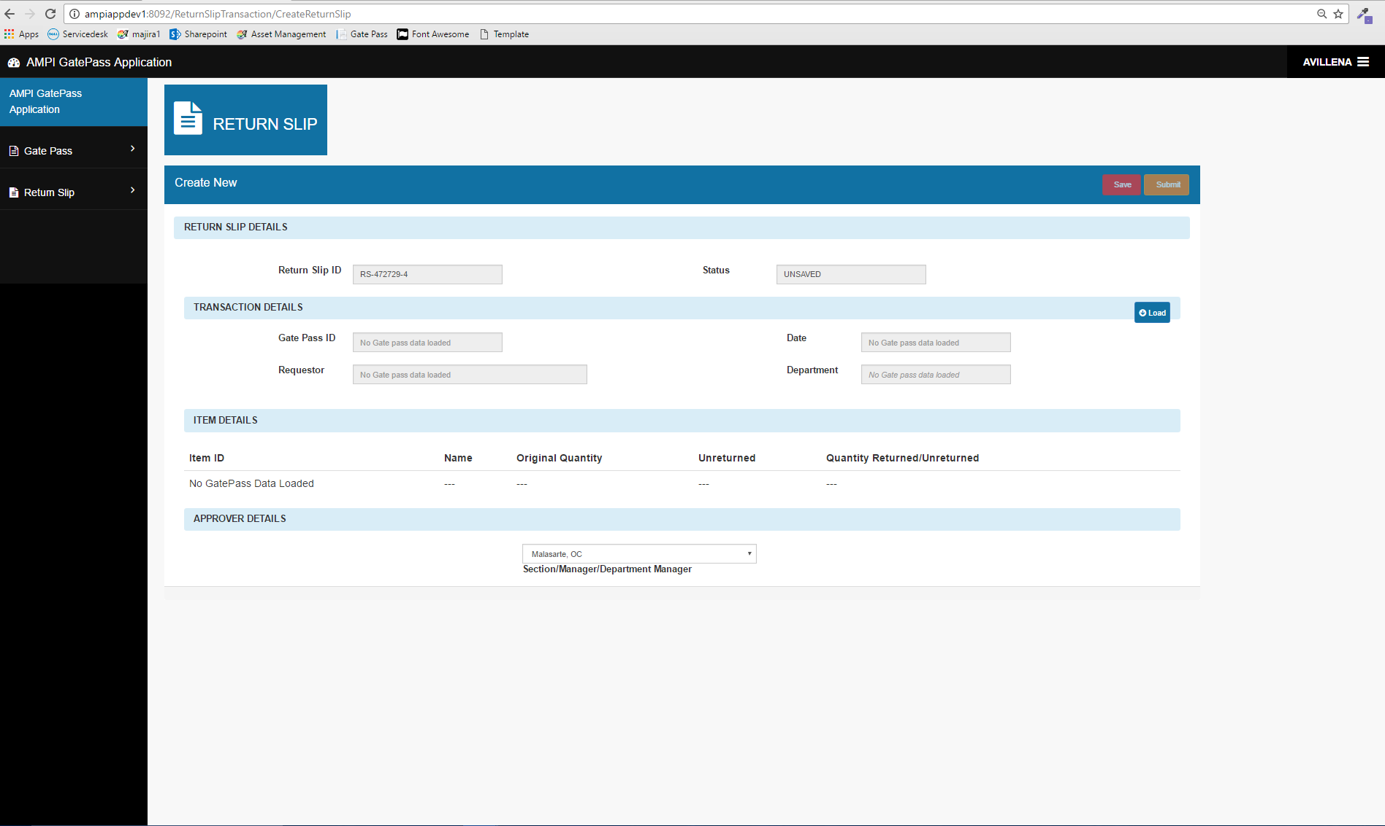

Return Slip Menu -> Create New Return Slip -> Load

* Load Gate Pass details to create return slip

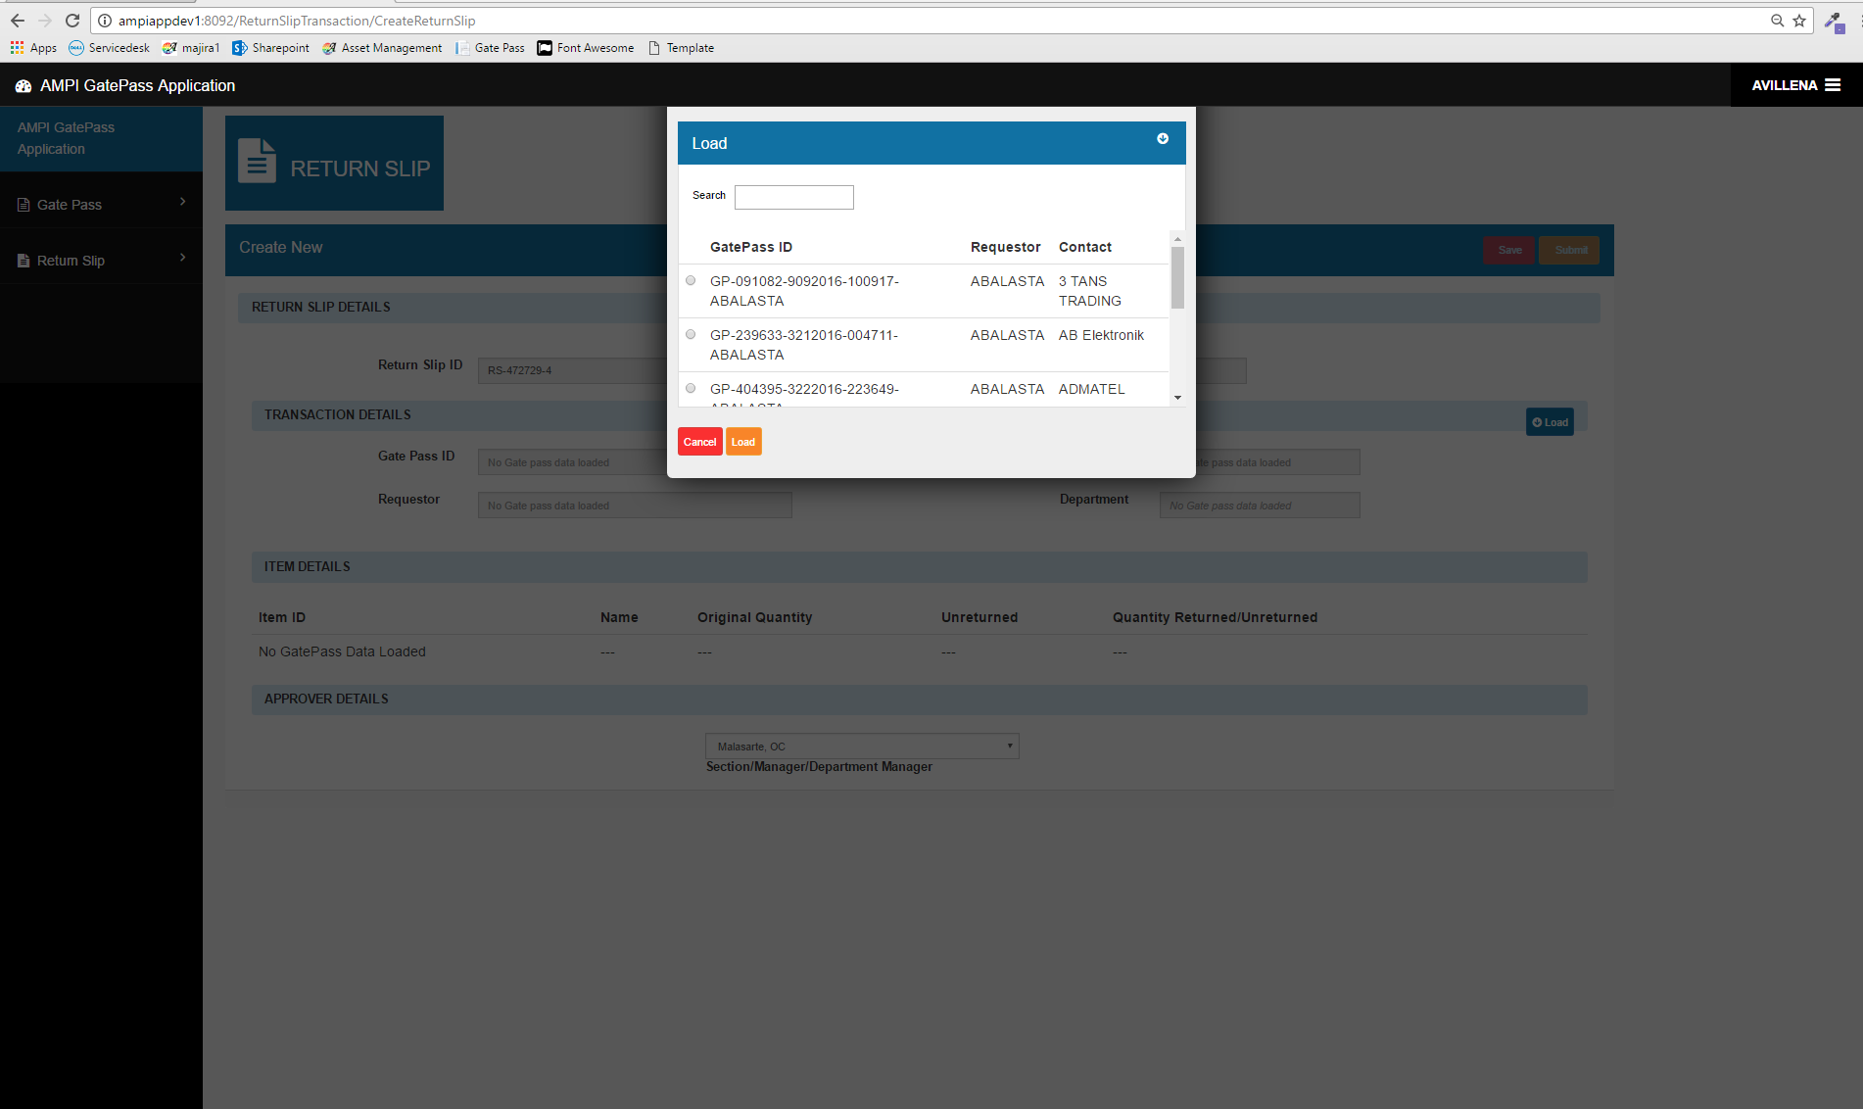

Return Slip Menu -> View of all Return Slip

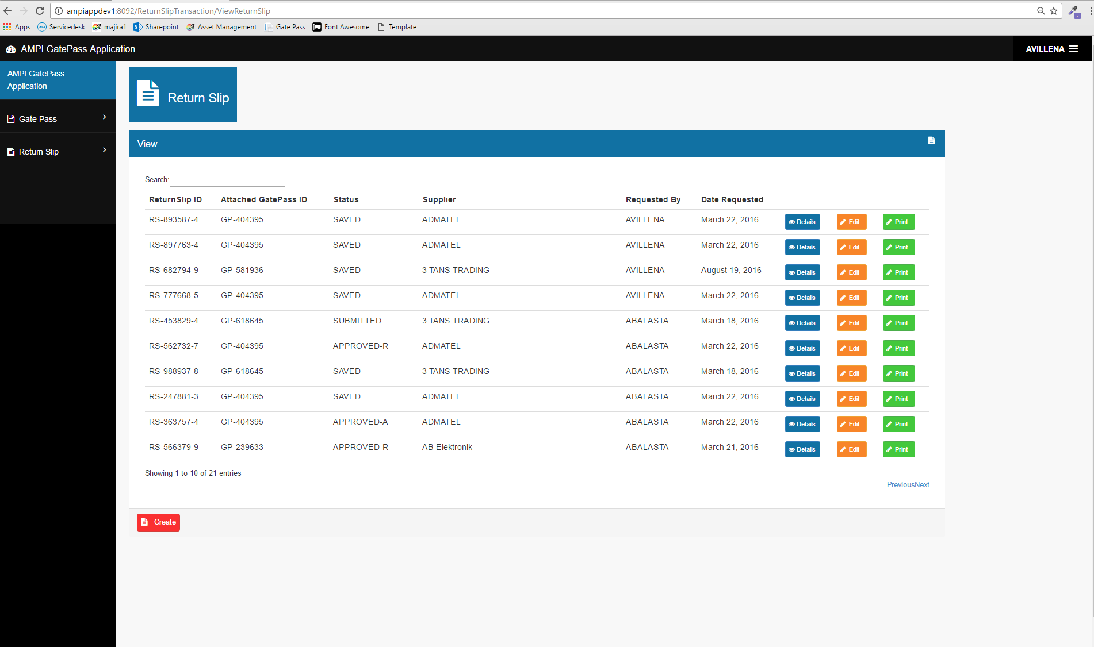

Return Slip Menu -> View of all Return Slip -> Details

* To view return slip details

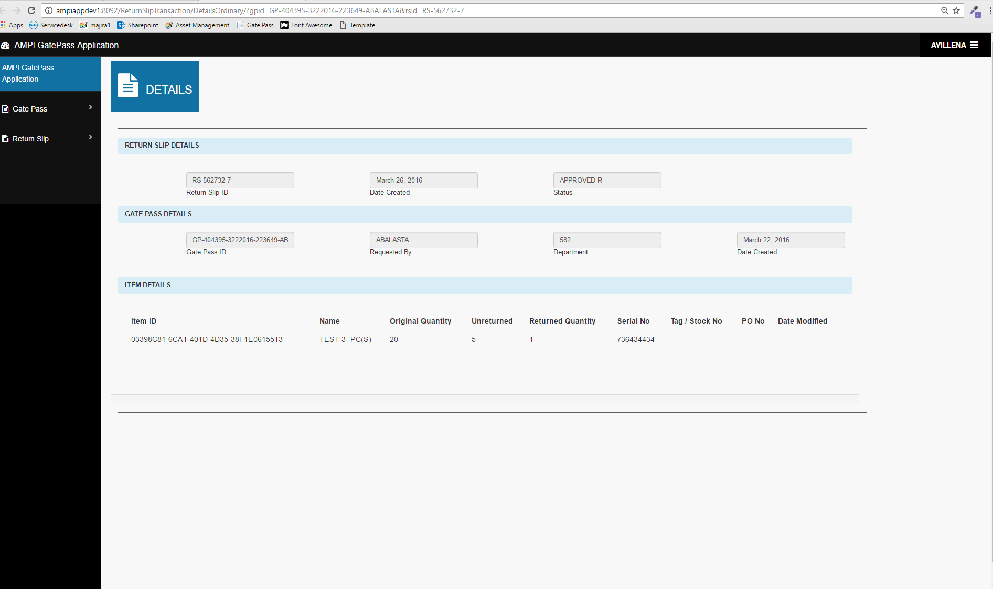

Return Slip Menu -> View of all Return Slip -> Edit

* Editable return slip details, Save as draft

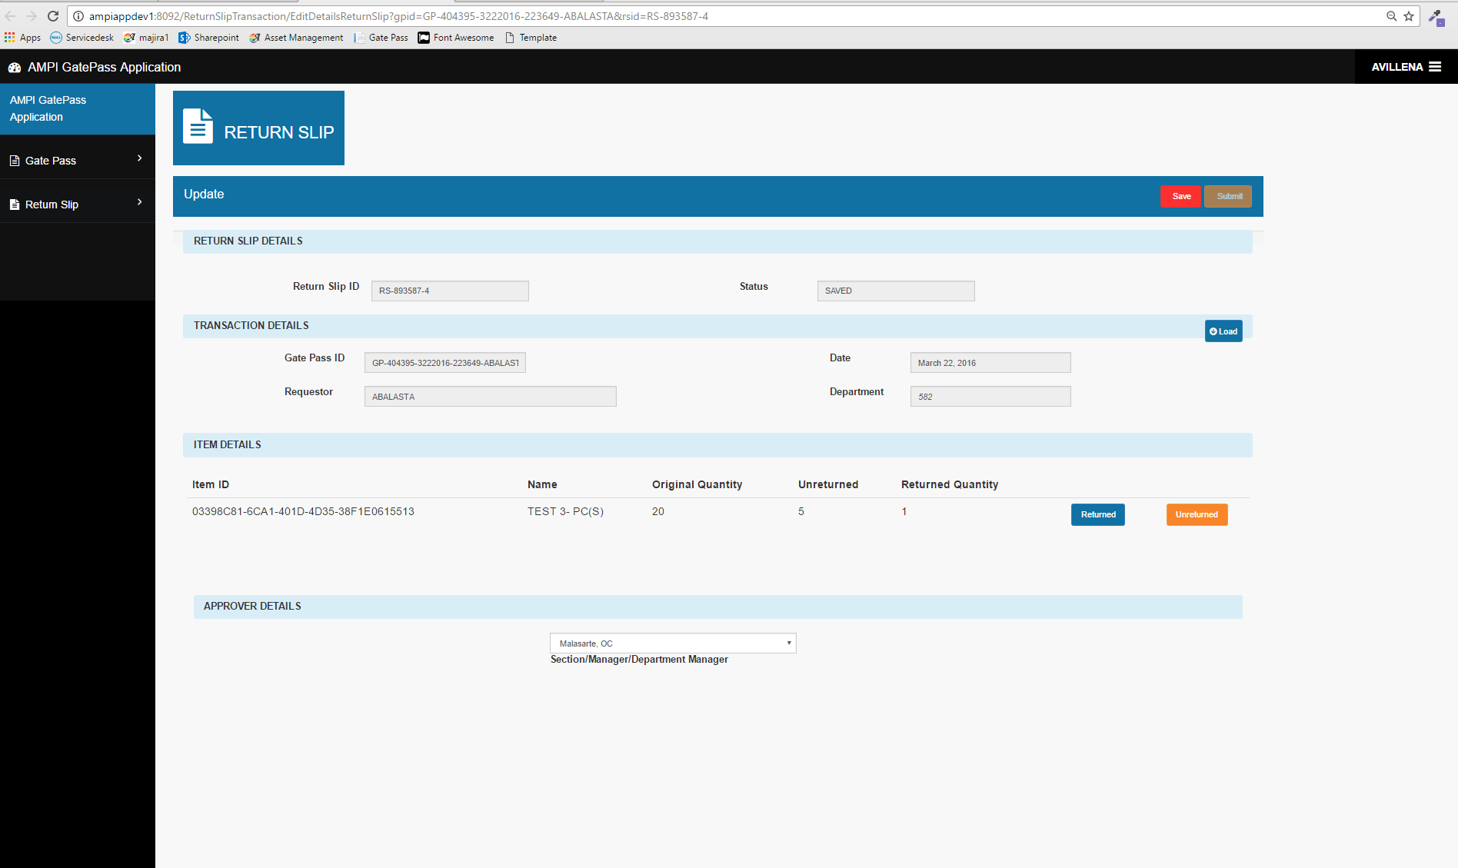

Return Slip Menu -> View of all Return Slip -> Print

* For hardcopy

